How to use Qwerofaucet.com

Visit: https://qwerofaucet.com/?r=EC-UserId-1554

The special thing about Qwerofaucetis that, depending on the runtime, you receive a payout (to EC) every minute - regardless of whether you closed the browser or the PC is off.
Visit Qwerofaucet again shortly before the claiming time expires and solve the shortlinks to extend the term.

Step 1: Login
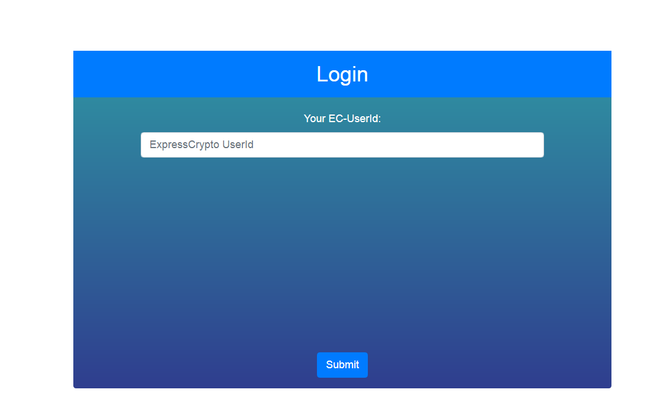
Enter your ExpressCrypto UserId and click Submit

Step 2: Shortlink

You will get redirected automatically to your shortlink.
Complete the shortlink's captcha
Step 3: Done

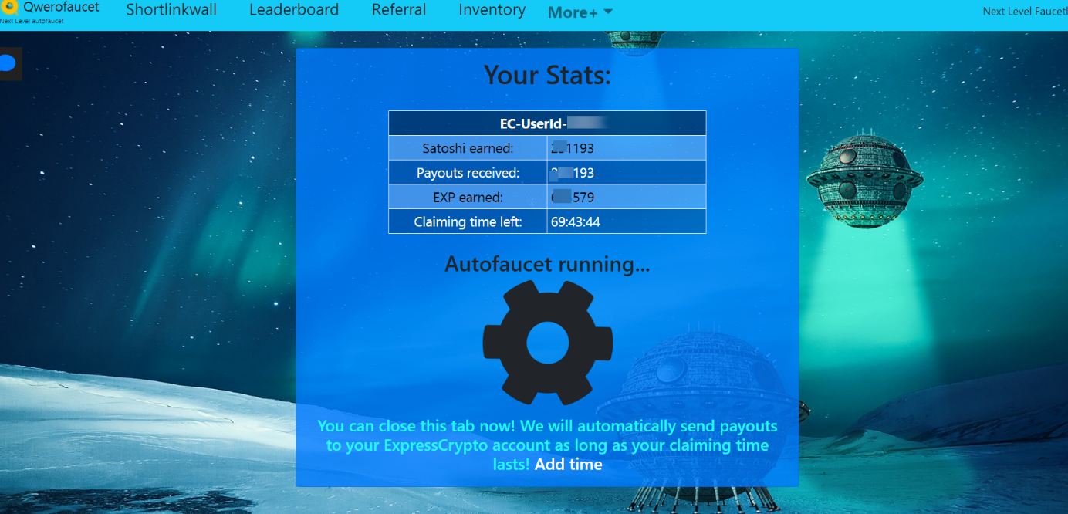
Done! You will now receive an automatic payment, which will be sent to your ExpressCrypto wallets.
Different coins are paid, DOGE, LTC or others.

You can check the payouts on ExpressCrypto by opening the bar below
- Your Recent Income in last 24 hours -

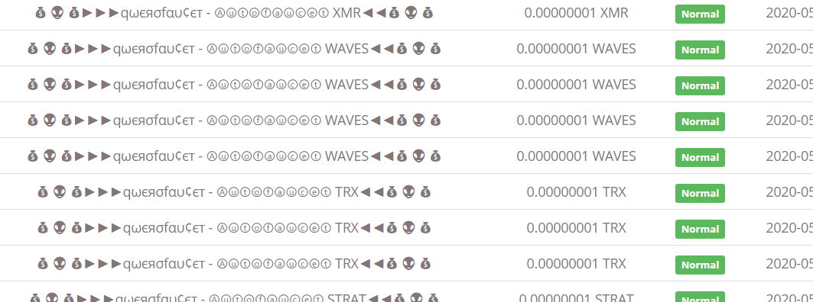

Step 4: Add more time

You can extend the term at any time via -Shortlinkwall-.
Up to 4 hours are possible
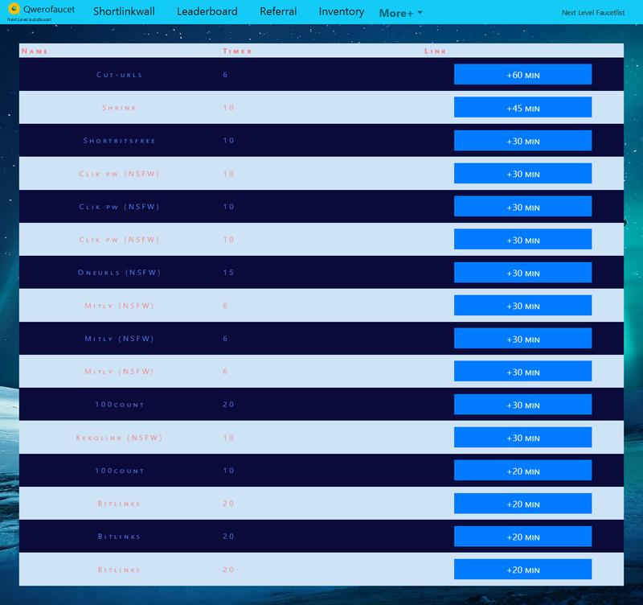

The special thing about Qwerofaucetis that, depending on the runtime, you receive a payout (to EC) every minute - regardless of whether you closed the browser or the PC is off.
Visit Qwerofaucet again shortly before the claiming time expires and solve the shortlinks to extend the term.

